SUMMER TRAINING REPORT

**On**

**Machine Learning**

### Submitted to[Guru Gobind Singh Indraprastha University, Delhi (India)](https://www.google.co.in/url?sa=t&rct=j&q=&esrc=s&source=web&cd=1&ved=0CC0QFjAA&url=http%3A%2F%2Fwww.ggsipu.nic.in%2F&ei=vfIaUvV0wv-IB9nFgIAI&usg=AFQjCNFGwnhD8_pGr-fs5uw5WWtLN3dUYg&sig2=m6ysfK3TOY9J2VMB7gvtww)

in partial fulfillment of the requirement for the award of the degree of

**B.TECH**

**in**

**INFORMATION TECHNOLOGY**

**Submitted By**

**ANMOL ASHRI**

**ROLL No. 40715003117**



**DEPT. OF INFORMATION TECHNOLOGY**

**MAHARAJA SURAJMAL INSTITUTE OF TECHNOLOGY,**

**NEW DELHI-110058**

**NOVEMBER**

**ACKNOWLEDGEMENT**

A project work owes its success from commencement to completion, to the people in love with developers at various stages. Let me in this page express my gratitude to all those who helped us in various stage of this project. First, I would like to express my sincere gratitude indebtedness to **Dr. Anupama Kaushik** (HOD, Department of Information Technology, Maharaja Surajmal Institute of Technology New Delhi) for allowing me to undergo the summer training of 8 weeks at **Coursera.**

I am grateful to our guide **Ms Jyoti Arora**, for the help provided in completion of the project, which was assigned to me. Without her friendly help and guidance it was difficult to develop this project.

I am also thankful to **Mr Surender Singh** for helping me to prepare the final report and presentation.

Last but not least, I pay my sincere thanks and gratitude to all the mates for their support and for making our training valuable and fruitful.

Submitted By:

ANMOL ASHRI

(40715003117)

**CERTIFICATE**

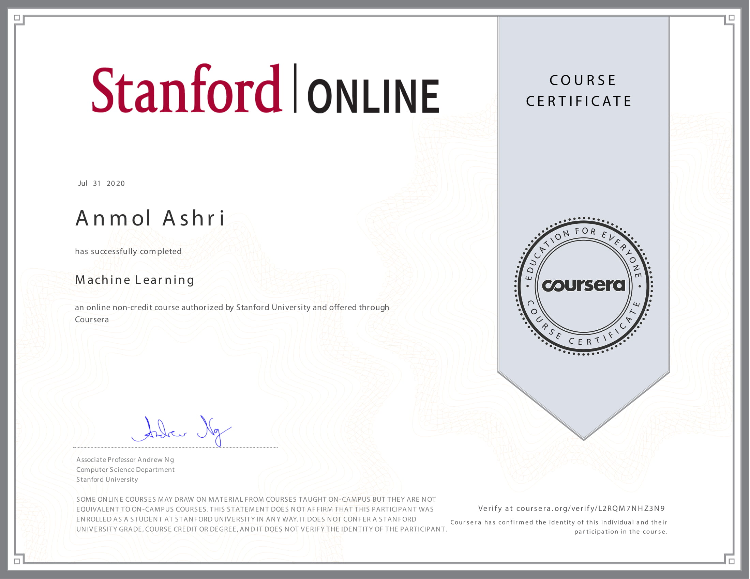

**CANDIDATE’S DECLARATION**

I, **ANMOL ASHRI**, Roll No - **40715003117**, B.Tech (Semester- 7th ) of the Maharaja Surajmal Institute of Technology, New Delhi hereby declare that the Training Report entitled **“Machine Learning”** is an original work and data provided in the study is authentic to the best of my knowledge. This report has not been submitted to any other Institute for the award of any other degree.

**ANMOL ASHRI**

**(40715003117)**

**Place: New Delhi**

**Date: 9 November’2020**

**Coursera**

Coursera was founded by Daphne Koller and Andrew Ng with a vision of providing life-transforming learning experiences to anyone, anywhere. It is now a leading online learning platform for higher education, where 73 million learners from around the world come to learn skills of the future. More than 200 of the world’s top universities and industry educators partner with Coursera to offer courses, Specializations, certificates, and degree programs. Thousands of companies trust the company’s enterprise platform Coursera for Business to transform their talent. Coursera for government equips government employees and citizens with in-demand skills to build a competitive workforce. Coursera for Campus empowers any university to offer high-quality, job-relevant online education to students, alumni, faculty, and staff. Coursera is backed by leading investors that include Kleiner Perkins, New Enterprise Associates, Learn Capital, and SEEK Group.

Coursera works with universities and other organizations to offer online courses, certifications, and degrees in a variety of subjects, such as engineering, data science, machine learning, mathematics, business, financing, computer science, digital marketing, humanities, medicine, biology, social sciences, 4500 plus variety of courses giving students a very broad range of information & experience in different fields.

**LIST OF FIGURES**

**Figure 1:** Rate of spread of Covid-19 in India....…………...……………..…………**14**

**Figure 2:** Number of Confirmed cases in India…...…………………...……………..**14**

**Figure 3:** Number of Confirmed cases in India per day…….………...……………..**14**

**Figure 4:** State Wise Covid-19 Trend in India.…...…………………...……………..**15**

**Figure 5:** Distribution of test conducted by each state…...…………...……………..**16**

**Figure 6:** Distribution of medical facilities…..…...…………………...……………..**17**

**Figure 7:** Number of Beds state-wise………..…...…………………...……………..**18**

**Figure 8:** Trend and weekly analysis………...…...…………………...……………..**19**

**Figure 9:** Prediction of Total number of cases using FB prophet model.……………**20**

**Figure 10:** Prediction of Total number of cases using ARIMA and ACF..…………..**20**

**Figure 11:**Prediction of Total number of cases using ARIMA …...……...…………..**21**

**Figure 12:** Prediction of minimum number of beds using FB prophet model………..**23**

**Figure 13:** Trend and weekly analysis……………..…………………...……………..**23**

**Figure 14:** Prediction of minimum number of hospital beds and ACF...……………..**24**

**Figure 15:** Prediction of minimum number of hospital beds and ACF...……………..**24**

**Figure 16:** Prediction of minimum number of hospital beds ……….....……………..**24**

**Figure 17:** Prediction of minimum number deaths using FB prophet model……….....**26**

**Figure 18:** Trend and weekly analysis…………………………………………..……..**26**

**Figure 19:** Prediction of minimum number of Deaths and ACF……...………..……..**27**

**Figure 20:** Prediction of minimum number of Deaths…………...……………..……..**27**

**CONTENT**

|  |  |  |
| --- | --- | --- |
| SNo. | Topic | Page No. |
|  |  |  |
| 1. | INTRODUCTION TO MACHINE LEARNING | 1-3 |
|  | 1.1How to approach Machine Learning? | 1 |
|  | 1.2 Explanation of Approach | 2 |
|  |  |  |
| 2. | MACHINE LEARNING ALGORITHMS | 4-7 |
|  |  |  |
| 3. | ABSTRACT | 7-8 |
|  |  |  |
| 4. | INTRODUCTION TO PROJECT | 8-9 |
|  |  |  |
| 5. | PREDICTION MODELS | 9-11 |
|  |  |  |
|  | 5.1 ARIMA | 9-10 |
|  | 5.2 FB Prophet | 10-11 |
|  |  |  |
| 6. | DATASET | 12 |
|  | 6.1 NOVEL CORONAVIRUS 2019 DATASET | 12 |
|  | 6.2 COVID-19 in INDIA DATASET | 12 |
|  |  |  |
| 7. | VISUALIZATION AND EXPERIMENTAL RESULTS | 13-28 |
|  |  |  |
|  | 7.1 VISUALIZATION | 13 |
|  | 7.1.1 RATE OF SPREAD | 13-14 |
|  | 7.1.2 HEALTHCARE SYSTEM | 14-17 |
|  | 7.2 EXPERIMENTAL RESULTS | 18 |
|  | 7.2.1 PREDICTION OF TOTAL NUMBER OF CASES | 18-21 |
|  | 7.2.2 PREDICTION OF HOSPITAL BEDS | 22-25 |
|  | 7.2.3 PREDICTION OF TOTAL NUMBER OF DEATHS | 23-28 |
|  |  |  |
| 8. | CONCLUSION | 28 |
| 9. | REFERENCES AND BIBLIOGRAPHY | 29-30 |
|  |  |  |
|  |  |  |
|  |  |  |
|  |  |  |
|  |  |  |
|  |  |  |
|  |  |  |
|  |  |  |
|  |  |  |
|  |  |  |
|  |  |  |
|  |  |  |
|  |  |  |
|  |  |  |